HOTEL REVENUE ANALYSIS
MODULE 1
- Objective
In this module, our goal is to create the dataset containing tables like Booking, Customer, Branch, RoomType and Date. Then load the dataset in Power Bi and create a Star schema.
2. Creation of the Dataset
2.1 Creation of Customer Table
- Create a table with the following columns:
CustomerID, Name, Email, Phone, Nationality, LoyaltyTier, AgeGroup and Gender.
- Generate around 4000 records for this table.
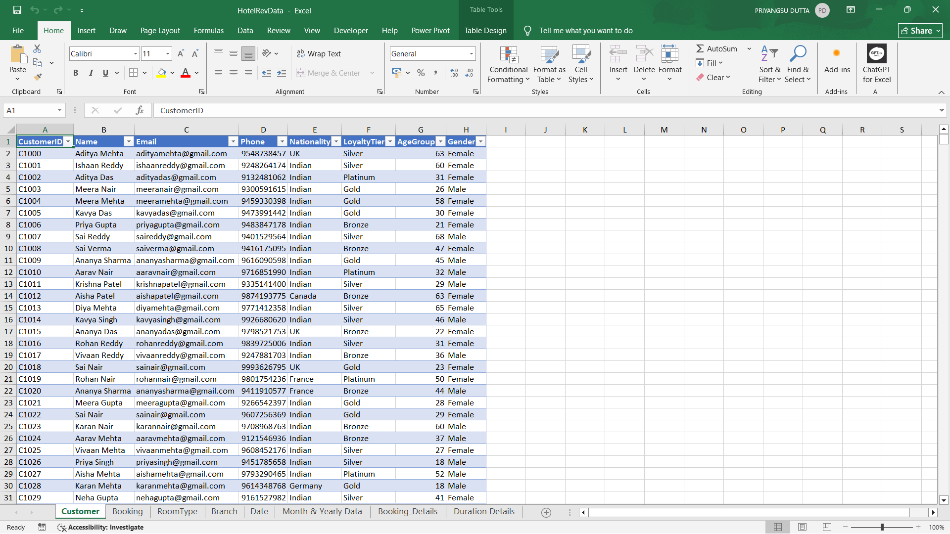
2.2 Creation of Booking Table
- Create another table with the following columns:
BookingID, CustomerID, RoomType, BranchID, CheckInDate, CheckOutDate, Duration, Revenue, BookingStatus, CancellationReason, LeadTime, PaymentMethod, DiscountApplied, BookingChannel, Purpose.
- Generate around 25000 records.
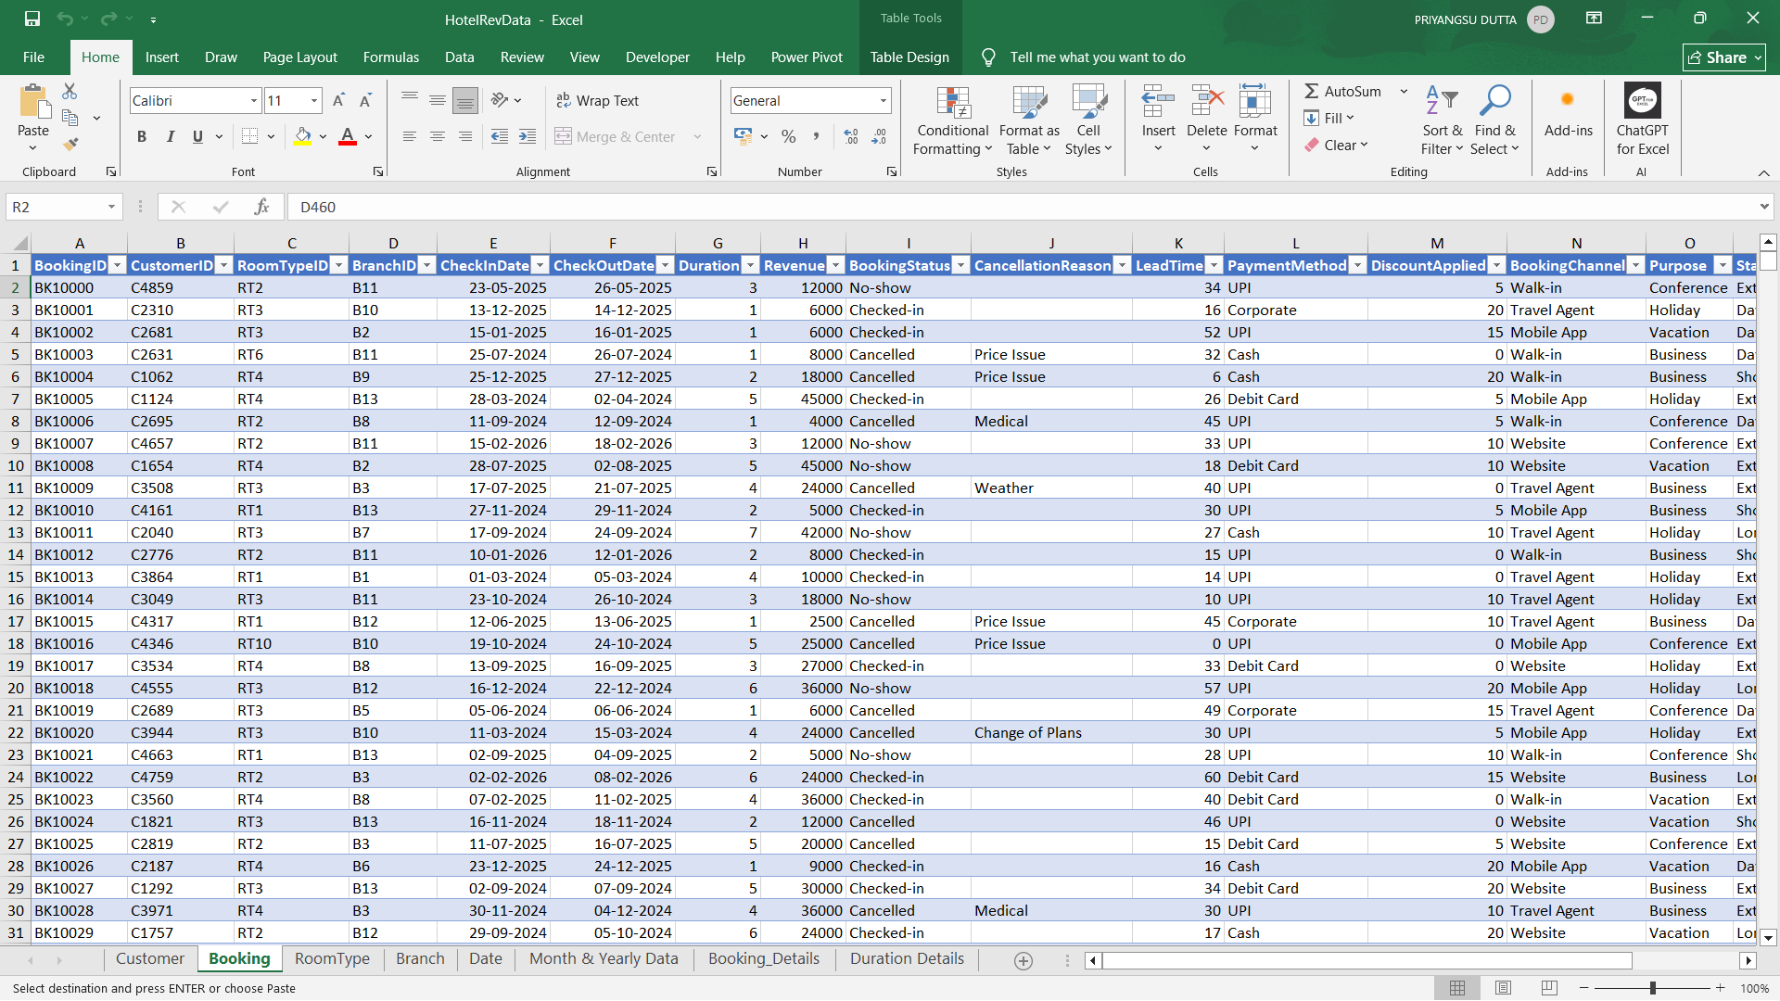
2.3 Creation of Branch Table
- Create another table with the following columns:
BranchID, BranchName, City, State, StarRating, RoomCount, ManagerName, PhoneNo.
- Generate atleast 10-15 records.
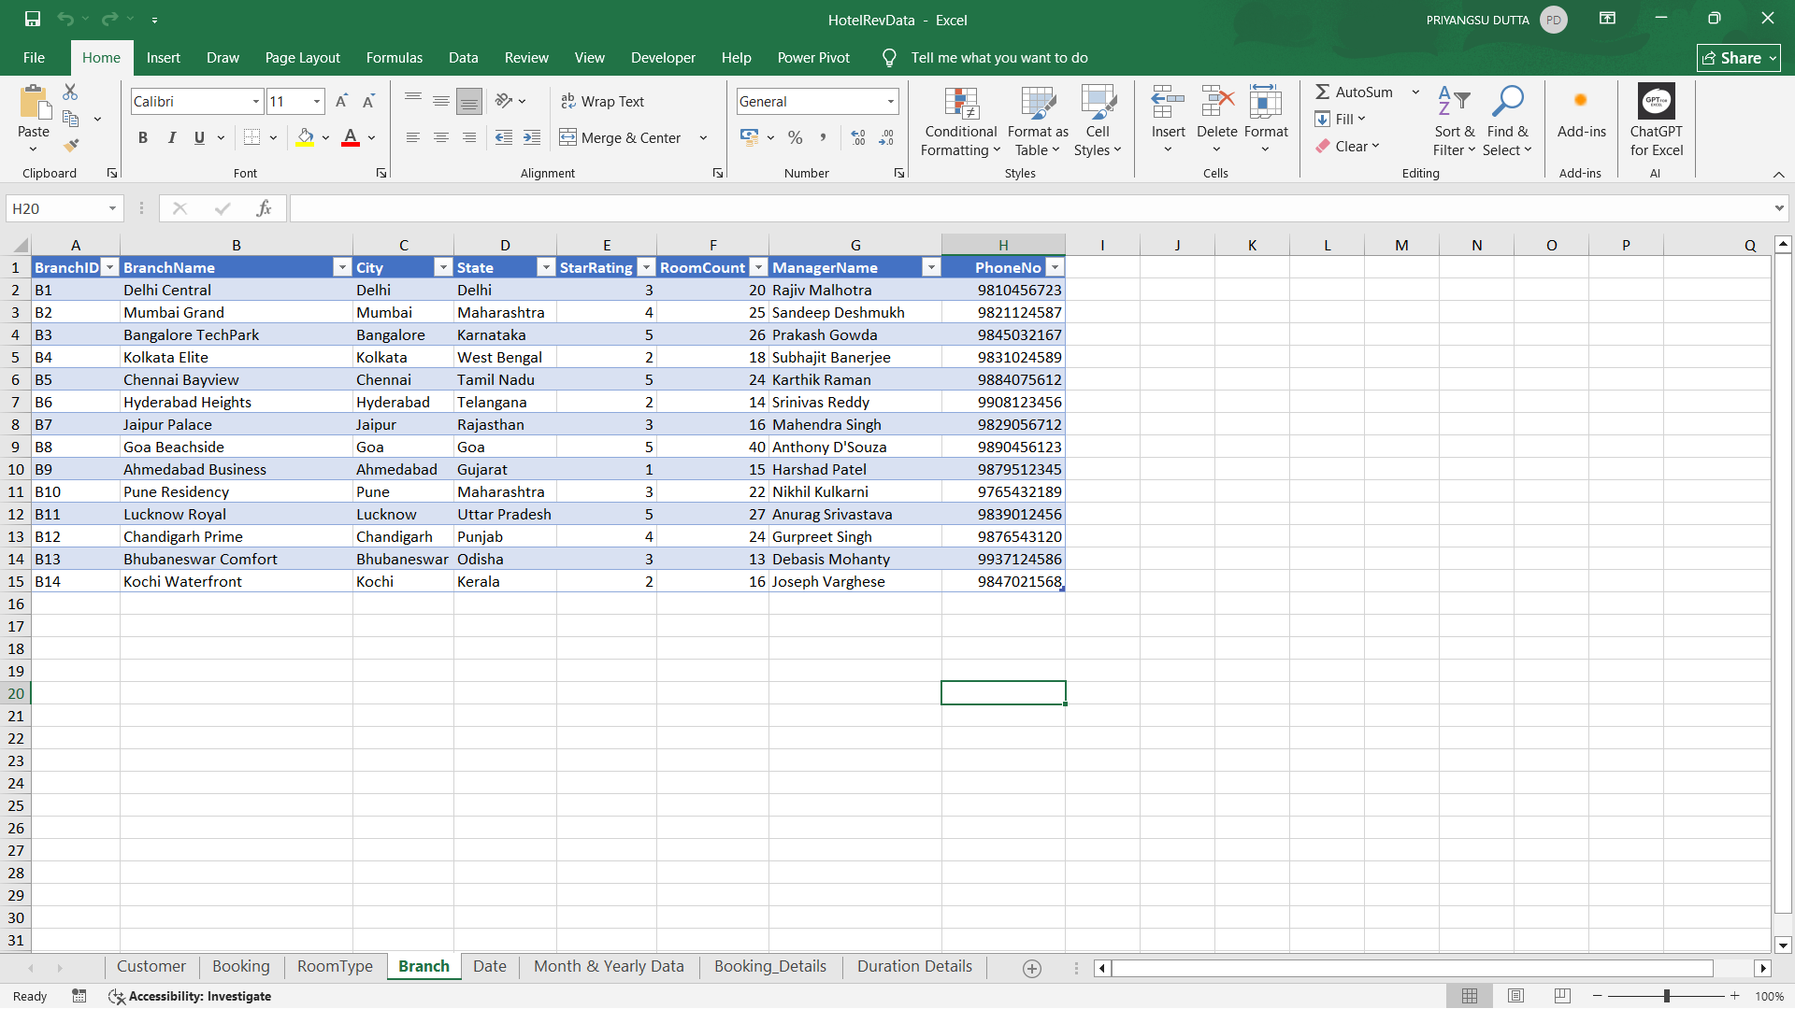

2.4 Creation of RoomType Table
- Create one more table with the following columns:
RoomTypeID, RoomType, Price, MaxOccupancy, Amenities, IsAC, IsSeafacing.
- Generate atleast 10 records.
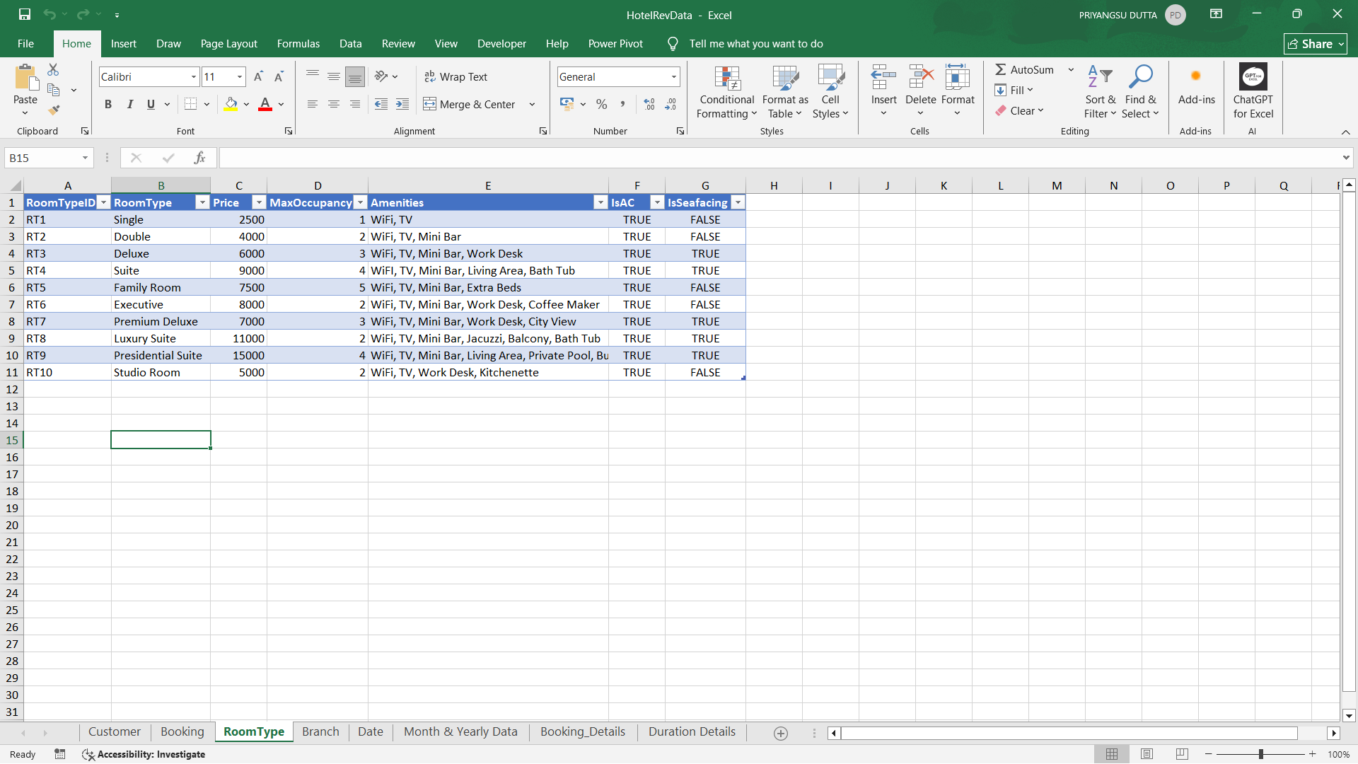
2.5 Creation of Date Table
- Create a table with the following columns:
- DateID
- CheckingDate (from Booking table)
- Day -> =DAY(B2)
- Month -> =MONTH(B2)
- Year -> =YEAR(B2)
- Weekday -> =TEXT(B2,"ddd")
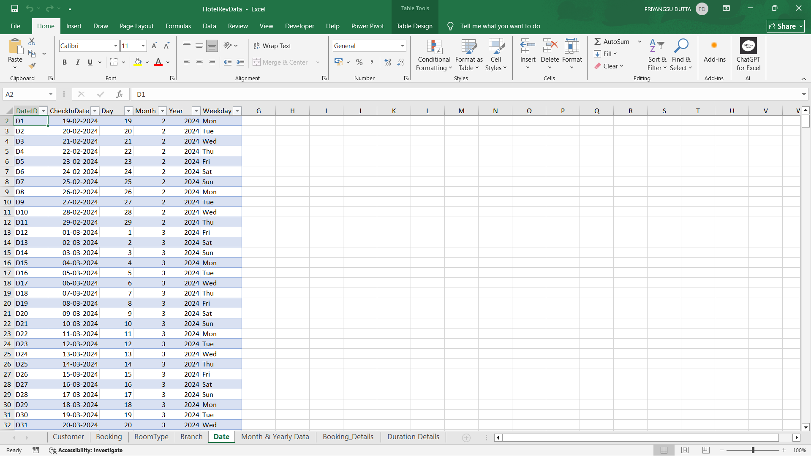
- Generate the records using the formulas mentioned above.

  - Enhancing Booking Table
- Create the following columns using the formulas mentioned below:
- StayType-> =IFS(G2=1,"Day Use",G2<=2,"Short Stay",G2<=5,"Extended Stay",G2>=6,"Long Stay")
- RoomNightSold -> =SUMIFS(G2, I2, "Checked-In")
- DateID (according to the Date table)

- Make sure to keep all the tables in one excel workbook.

3. Load & Creation of Star Schema in Power BI
3.1 Load the Dataset in Power BI
- Open Power BI Desktop. Go to Get Data -> Excel workbook -> choose your file.
- In the opened pop up, select all the tables created before and click Load.
- The dataset will be loaded in Power BI.
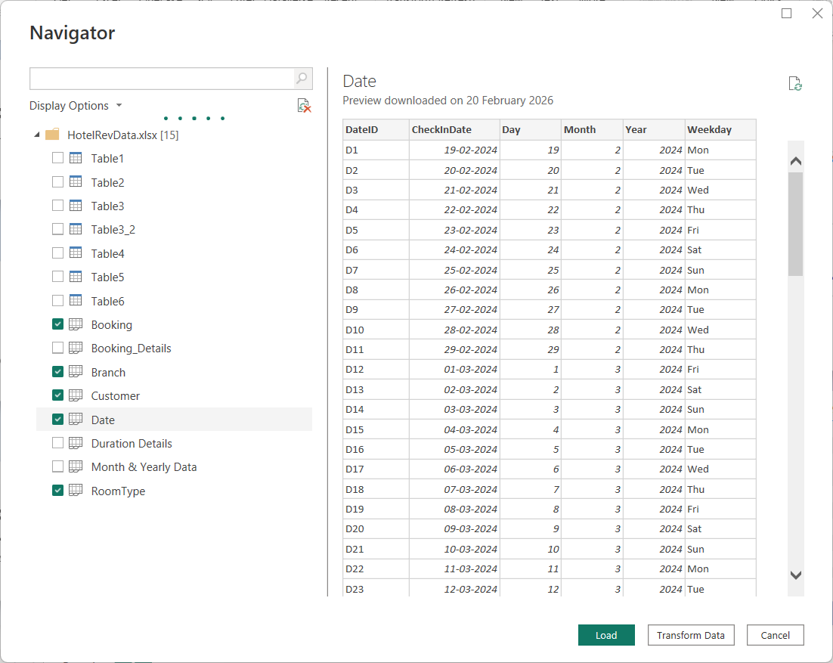

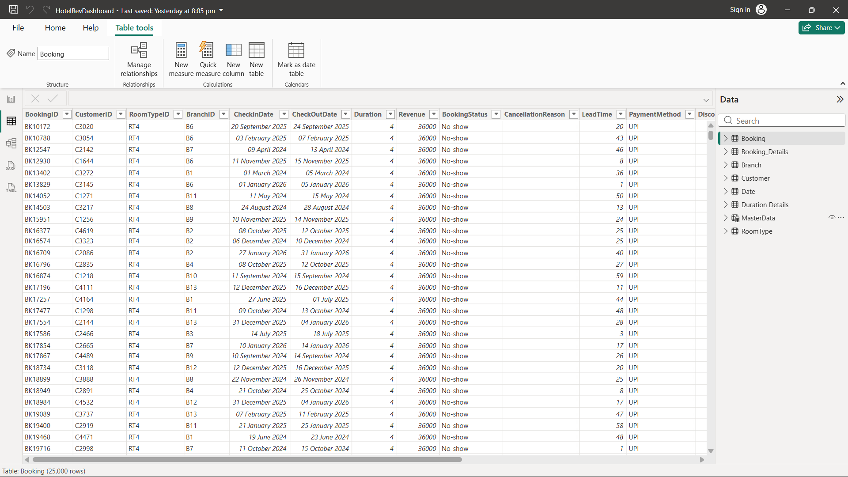

3.2 Creation of Star Schema
- After loading the data into Power BI, the star schema will automatically be created. Click Model View in the left side and check the star schema.
